BragBoard Project – Work Progress Documentation
Project Title: BragBoard – Internal Employee Recognition Wall
Tech Stack: FastAPI (Backend), React.js + Tailwind CSS (Frontend), PostgreSQL (Database), JWT Authentication

1. Project Understanding & Initial Planning
- Studied the BragBoard problem statement and project scope.
- Understood the goal of building an internal employee recognition platform with authentication, role management, and department-based access.
- Analyzed the 8-week milestone plan and identified Weeks 1–2 as the current focus.
- Finalized the technology stack as per project requirements:
  - Backend: FastAPI
  - Database: PostgreSQL
  - Authentication: JWT-based login system
  - Frontend: React with Tailwind CSS (basic setup initiated)

2. Backend Project Setup (Week 1 – Foundation)
Environment Setup
- Created a dedicated backend workspace with a virtual environment.
Backend Virtual Environment Configuration
- Created a dedicated Python virtual environment (venv) for the backend.
- Purpose of using venv:
  - Isolates project dependencies from global Python installation.
  - Prevents version conflicts between libraries.
  - Ensures consistent execution across systems.
- Activated the virtual environment before installing any backend dependencies.
- Installed all backend libraries inside the virtual environment only.
- Verified that FastAPI and Uvicorn run successfully inside the venv.
Validation Performed:
- Backend server runs only when venv is activated.
- All installed packages are scoped to the project environment.

- Installed and verified all required backend dependencies.
- Ensured FastAPI server runs successfully using Uvicorn.

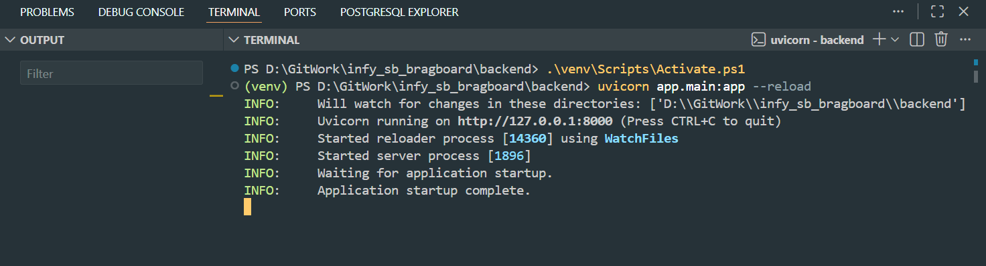

Backend Folder Structure Design
- Organized backend code into modular and scalable components:
  - Application entry point
  - Database configuration
  - Models for database tables
  - Schemas for request/response validation
  - Routers for API endpoints
  - Authentication utilities
- Followed clean architecture principles to separate concerns.
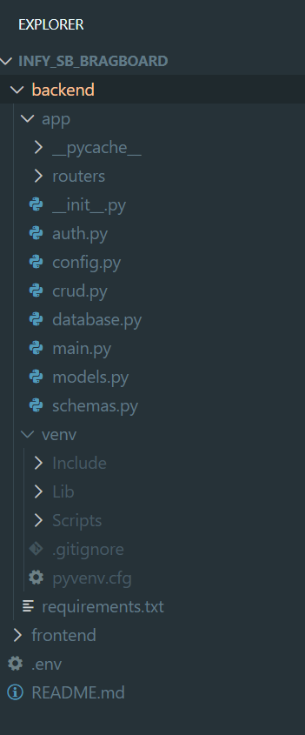

3. Database Configuration & Integration
- Configured PostgreSQL as the primary database.
- Established a secure database connection using environment-based configuration.
- Designed database schema according to the BragBoard specification:
  - Users table with role and department fields.
- Ensured tables are auto-created during development for validation.
- Verified database connectivity through successful API interactions.

4. User Management & Authentication Implementation
User Registration
- Implemented a user registration flow.
- Captured essential user details:
  - Name
  - Email
  - Password
  - Department
  - Role (employee/admin)
- Applied proper validation rules for inputs.
- Secured user credentials using password hashing.
- Ensured duplicate email registrations are prevented.
User Login
- Implemented secure login functionality.
- Validated user credentials against stored records.
- Generated JWT access tokens upon successful authentication.
- Ensured invalid credentials are handled gracefully.
Authentication Validation
- Implemented protected endpoints that require authentication.
- Verified token-based access control.
- Tested authenticated user identification using token validation.
- Confirmed that only logged-in users can access secured routes.
Backend API Testing & Documentation Using Swagger UI
- Used Swagger UI, which is automatically provided by FastAPI, for backend API documentation and testing.
- Swagger UI provides an interactive web interface to test API endpoints without using external tools.
- All user-related endpoints (registration, login, protected routes) were tested using Swagger UI.
- Verified request and response formats directly through the interface.
- Used Swagger UI to test authenticated endpoints by passing JWT access tokens.
- Validated API behavior for:
  - Successful requests
  - Invalid inputs
  - Unauthorized access
- Ensured backend logic works correctly before connecting it to the frontend.
Benefits of Using Swagger UI:
- Faster backend debugging
- Clear API documentation
- Reduced dependency on third-party API testing tools
- Improved confidence before frontend integration
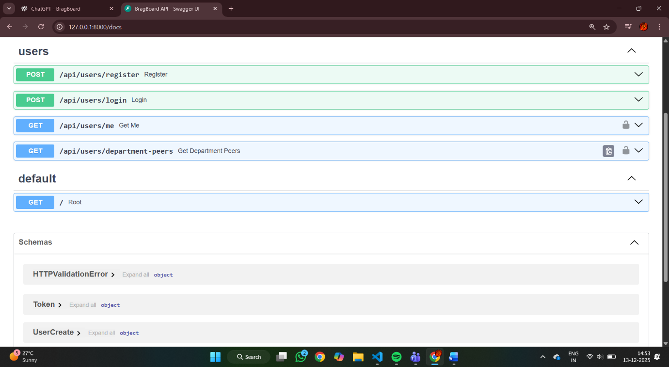

5. Role & Department Handling
- Implemented role-based user classification (employee/admin).
- Stored department information for each user.
- Verified department data persistence during registration.
- Ensured user role and department are retrievable after login.
- Validated admin and employee access logic for future features.

6. API Testing & Validation
- Tested the following scenarios:
  - Successful user registration
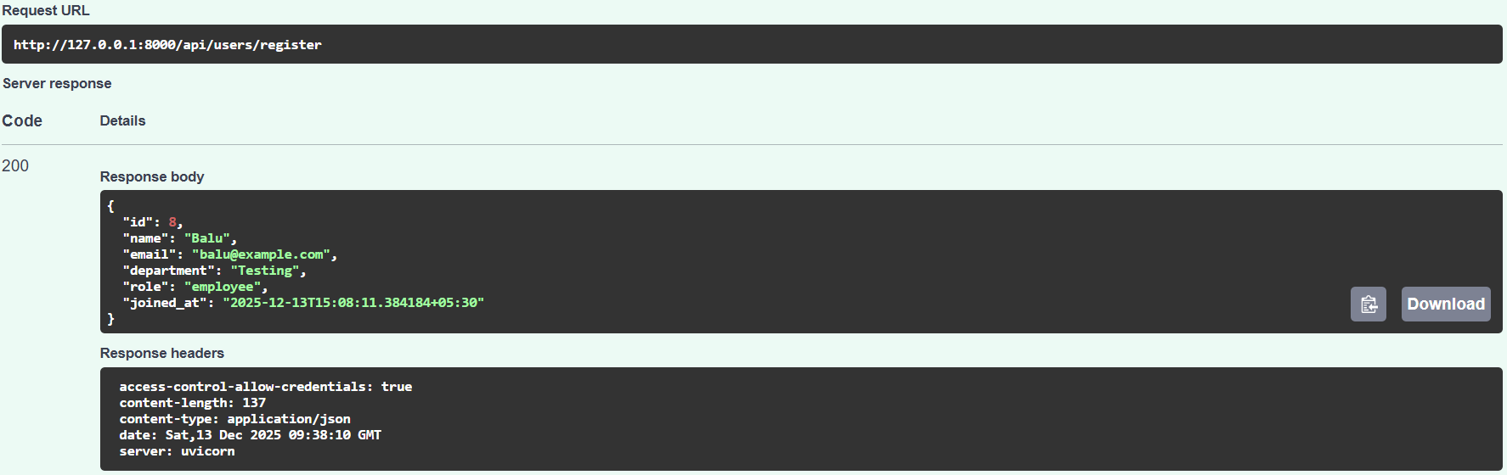

  - Duplicate user registration handling
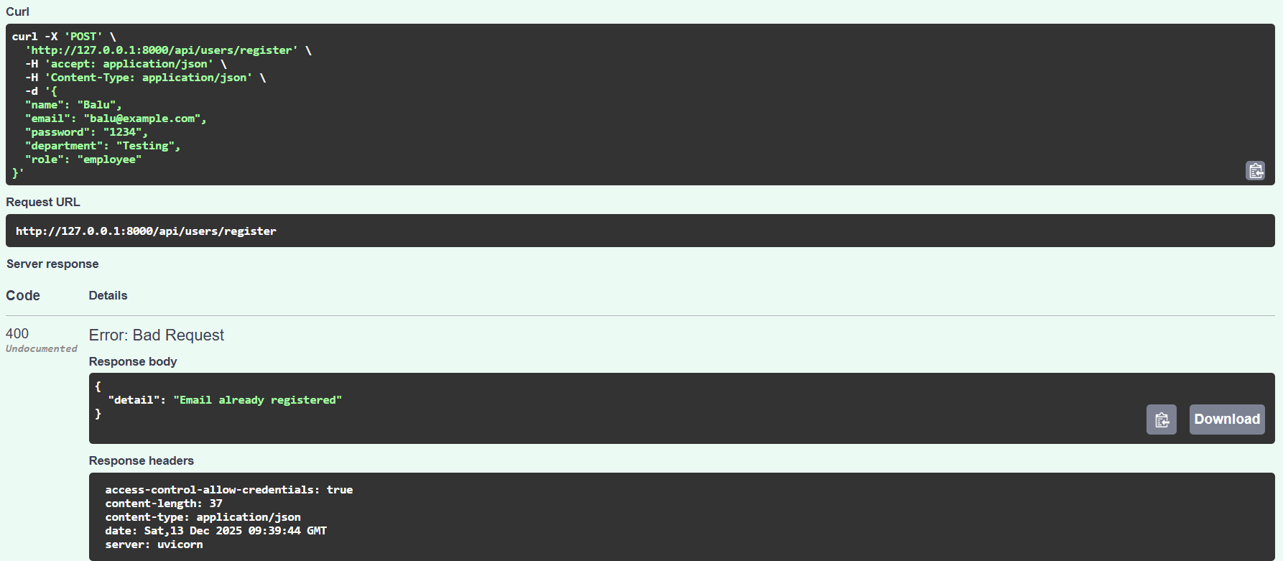

  - Successful login
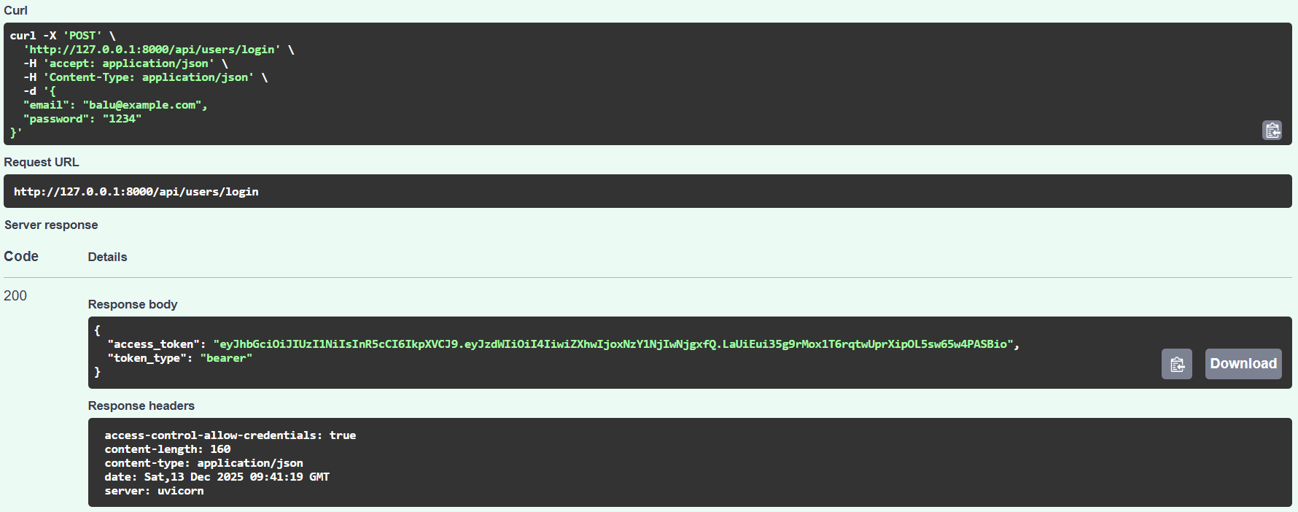
  - Invalid login attempts
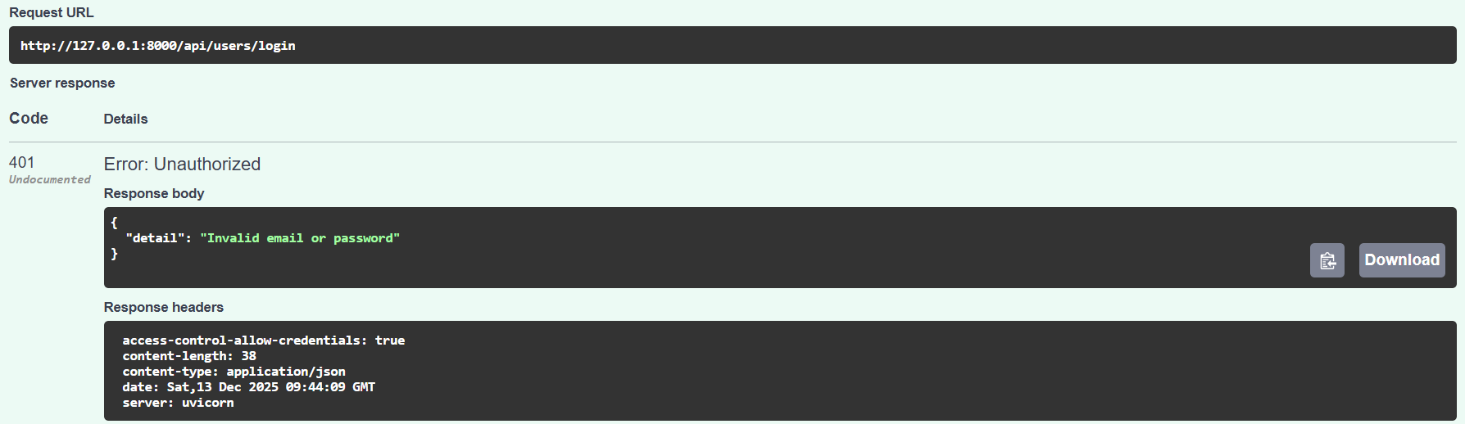

  - Accessing protected routes with valid and invalid tokens

- Verified consistent and correct API responses.
- Ensured backend stability after dependency fixes and version adjustments.

7. Frontend Initial Setup (Week 2 – Basic UI)
Frontend Environment Setup Using React & npm
- The frontend of the BragBoard project was developed using React.js.
- React requires Node.js and npm (Node Package Manager) to manage dependencies and run the development server.
- The React project was initialized using standard React project scaffolding.
- npm was used to:
  - Install React and related libraries
  - Manage frontend dependencies
  - Run the frontend development server
- The node_modules directory and package.json file were automatically generated as part of npm usage.
- The frontend application was successfully launched in the browser using npm commands.
Validation Performed:
- React development server starts successfully.
- Frontend pages load without errors.
- UI changes reflect immediately during development.
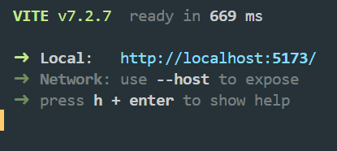

Frontend Initialization
- Created React project structure.
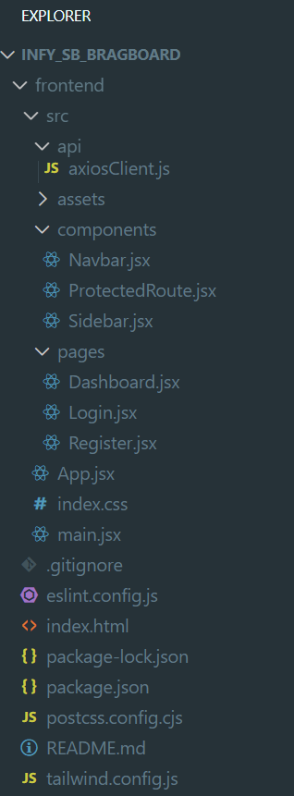
- Integrated Tailwind CSS for styling.
- Verified frontend application runs successfully.
Basic Pages Implemented
- Login page UI created.
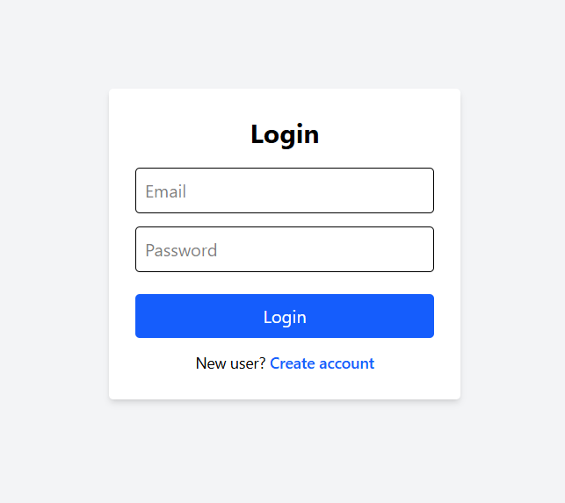
- Registration page UI created.
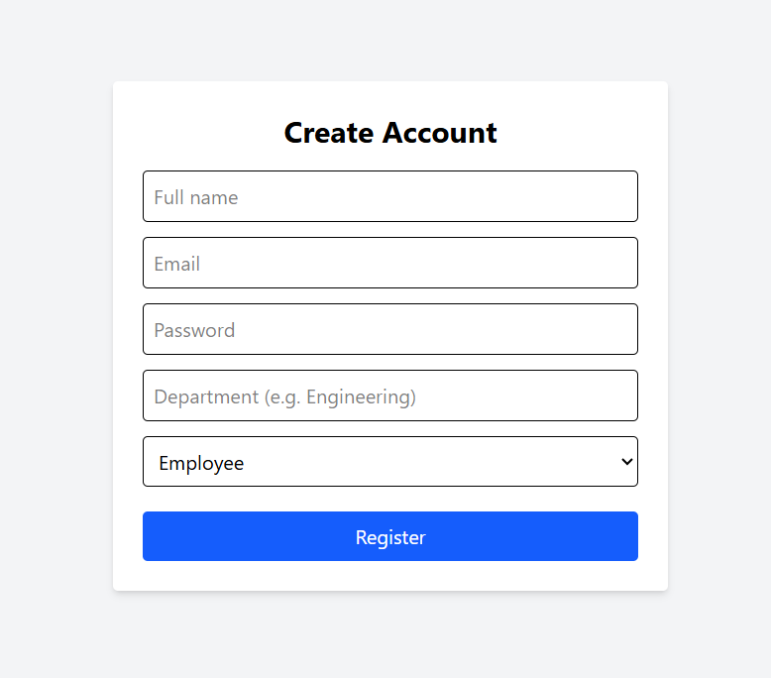
- Dashboard page layout initialized.
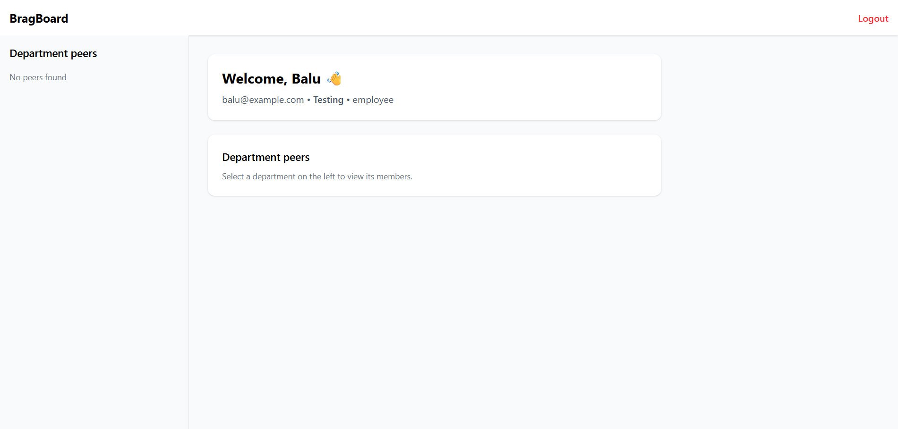
- Verified navigation between login, register, and dashboard.
Backend–Frontend Connection
- Connected frontend forms to backend APIs.
- Tested registration flow from frontend UI.
- Tested login flow from frontend UI.
- Verified successful redirection to dashboard after login.

8. Dashboard & User Display Validation
- Confirmed logged-in user data is accessible.
- Displayed user-specific information on dashboard.
- Validated that registered users appear correctly when logged in.
- Tested with multiple users and roles (admin and employee).
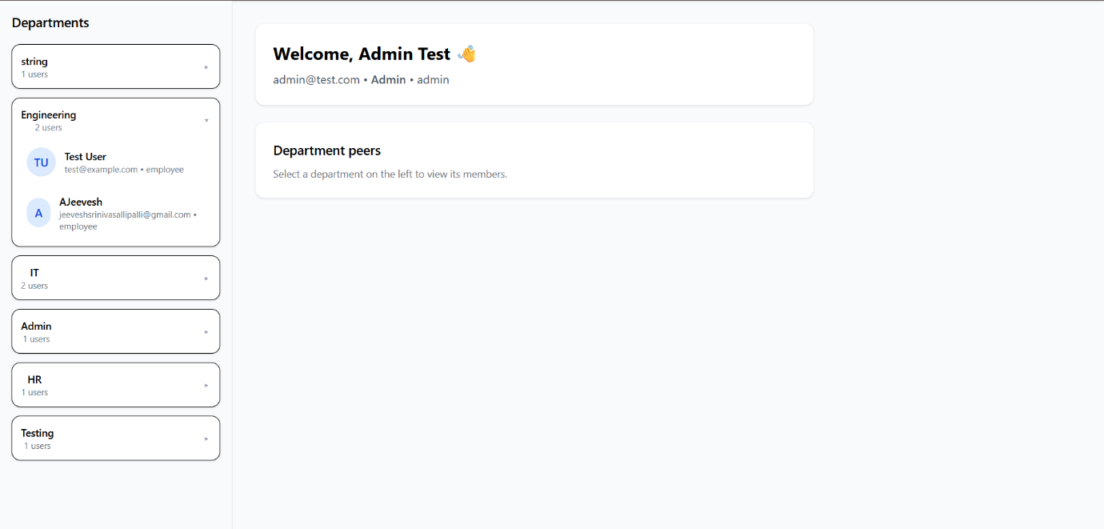

Version Fixes & Debugging
- Resolved dependency conflicts (Pydantic version changes).
- Fixed configuration warnings and validation issues.
- Ensured backend server stability after fixes.
- Confirmed that API behaviour remains consistent after updates.

Current Project Status
- Backend project setup with FastAPI
- PostgreSQL database integration
- User registration and login system
- JWT-based authentication
- Role and department management
- API testing and validation
- Frontend basic UI setup
- Login, registration, and dashboard flow
- Frontend–backend integration

The current implementation successfully completes the -
User System & Basic UI milestone (Weeks 1–2) as defined in the BragBoard project plan.
The system is stable, authenticated, and ready for extending into shout-out posting, reactions, and admin functionalities in upcoming weeks.

